**Problem statement**

We need to analyze key indictors for our pizza sales data to gain insights into our business performance.

Specifically we want to calculate the following metrics.

1. Total Revenue: the sum of the total price of all pizza orders:
2. Average order value: the average amount spent per order, calculated by diving the total revenue by the total number of orders.
3. Total Pizzas Sold: the sum of quantities of all pizzas sold
4. Total orders: the total number of orders placed.
5. Average pizzas per order: the average number of pizzas sold per order, calculated by diving the total number of pizzas sold by the total number of orders.

* **Analysed the total revenue of all pizza orders**
* **Discovered the average price per order.**
* **Discovered the total pizza orders within the year.**
* **Calculated the average pizza orders.**

**SQL Queries**

Question 1 Total revenue

To get the total revenue all we need to do is to add up all the total price of all the pizza and to do that we can use SUM to add up all the total price which is $817860.04

Question 2: the average order value.

To get the result of average order value we first need to add the total price which we use sum and then divide it by the order id. The count function is used to count up the order id but we also use distinct because we don’t want to add up duplicate values in order to get the average order value.

Question 3 Total Pizzas sold:

The total pizza sold would require us to query the sum of the quantity table.

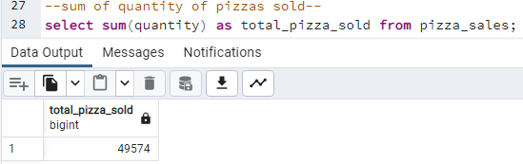

Question 4 Total Pizza orders

The total number of orders will require us to query and count the orders but don’t want to include duplicate values therefore we use the distinct function which only returns different values

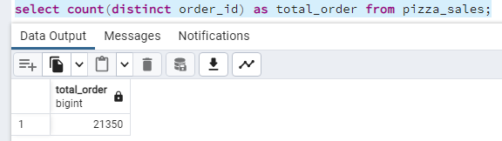

Question 5: average pizza orders

To get the average pizza orders we will need to calculate by diving the total number of pizzas sold by the total number of orders.

The query shows that we will need to cast is as a numeric in the precision scale and we can use round to round it down

